A
Mini Project Report on
ARTIFICIAL INTELLIGENCE FOR ANOMALY CLASSIFICATION IN SMART HOME SECURITY
Submitted for partial fulfilment of the requirements for the award of the degree of
BACHELOR OF TECHNOLOGY
in
DEPARTMENT OF COMPUTER SCIENCE & ENGINEERING
by
L. VYSHNAVI REDDY | 21K81A0537
P. RAHUL | 21K81A0552
R. ANVIKA | 21K81A0553

Under the Guidance of
K. GANAPATHI BABU
ASSISTANT PROFESSOR

DEPARTMENT OF COMPUTER SCIENCE AND ENGINEERING
St. MARTIN'S ENGINEERING COLLEGE
UGC Autonomous
Affiliated to JNTUH, Approved by AICTE,
Accredited by NBA & NAAC A+, ISO 9001:2008 Certified
Dhulapally, Secunderabad - 500 100
NOVEMBER- 2024

 | St. MARTIN'S ENGINEERING COLLEGE | 
UGC Autonomous
NBA & NAAC A+ Accredited
Dhulapally, Secunderabad - 500 100
www.smec.ac.in
Certificate

This is to certify that the project entitled “Artificial Intelligence for Anomaly Classification in Smart Home Security” is being submitted By L.Vyshnavi Reddy(21K81A0537),P.Rahul(21K81A0552),R.Anvika(21K81A0553),in fulfilment of the requirement for the award of degree of BACHELOR OF TECHNOLOGY in DEPARTMENT OF COMPUTER SCIENCE AND ENGINEERINGis recorded of bonafide work carried out by them. The result embodied in this report have been verified and found satisfactory.

Guide | Head of the Department
K. GANAPATHI BABU  Assistant Professor  Department of CSE | Dr. R. SANTHOSHKUMAR  Professor & Head  Department of CSE

Internal Examiner External Examiner
Place:
Date:

 | St. MARTIN'S ENGINEERING COLLEGE | 
UGC Autonomous
NBA & NAAC A+ Accredited
Dhulapally, Secunderabad - 500 100
www.smec.ac.in
DEPARTMENT OF COMPUTER SCIENCE AND ENGINEERING
DECLARATION

We, the students of ‘Bachelor of Technology in Department of Computer Science and Engineering’, session: 2021 - 2025, St. Martin’s Engineering College, Dhulapally, Kompally, Secunderabad, hereby declare that the work presented in this Project Work entitled “Artificial Intelligence for Anomaly Classification in Smart Home Security”is the outcome of our own bonafide work and is correct to the best of our knowledge and this work has been undertaken taking care of Engineering Ethics. This result embodied in this project report has not been submitted in any university for award of any degree.

L. Vyshnavi Reddy 21K81A0537
P. Rahul 21K81A0552
R. Anvika 21K81A0553

ACKNOWLEDGEMENT
The satisfaction and euphoria that accompanies the successful completion of any task would be incomplete without the mention of the people who made it possible and whose encouragement and guidance have crowded our efforts with success.
First and foremost, we would like to express our deep sense of gratitude and indebtedness to our college management for their kind support and permission to use the facilities available in the institute.
We extend our deep sense of gratitude to Group Director, Dr. P. SANTOSH KUMARPATRA, St. Martin’s Engineering College Dhulapally, for permitting us to undertake this project.
We wish to record our profound gratitude to Dr. M. SREENIVAS RAO, Principal, St. Martin’s Engineering College, for his motivation and encouragement.
We are also thankful to Dr. R.SANTHOSHKUMAR, Head of the Department, Department of Computer Science and Engineering, St. Martin’s Engineering College, Dhulapally, Secunderabad. for his support and guidance throughout our project as well as our Project Coordinators Mr. S.BAVANKUMAR, Assistant Professor, Department of Computer Science and Engineering for their valuable support.
We would like to express our sincere gratitude and indebtedness to our project supervisor MR. K. GANAPATHI BABU, Assistant Professor, Department of Computer Science and Engineering, St. Martins Engineering College, Dhulapally, for his support and guidance throughout our project.
Finally, we express thanks to all those who have helped us successfully completing this project. Furthermore, we would like to thank our family and friends for their moral support and encouragement. We express thanks to all those who have helped us in successfully completing the project.
L. Vyshnavi Reddy | 21K81A0537
P. Rahul | 21K81A0552
R. Anvika | 21K81A0553

ABSTRACT

The integration of artificial intelligence (AI) into smart home security systems has revolutionized the way we protect our homes and personal safety. With the increasing adoption of smart home devices, such as security cameras, motion detectors, and smart locks, the volume of data generated has surged. As of 2023, the global market for smart home security systems is estimated to exceed $40 billion, driven by advancements in technology and growing consumer demand for enhanced security. However, the vast amount of data collected presents a significant challenge in identifying and classifying anomalies that could indicate security breaches or other issues. Traditional security systems often rely on predefined rules and manual monitoring, which can be inadequate for handling the complexity and volume of data generated by modern smart home devices. Machine learning and AI offer a transformative approach to anomaly classification, enabling systems to automatically detect and respond to unusual patterns or behaviors. By employing techniques such as supervised learning, unsupervised learning, and deep learning, AI can analyze data from various sensors to identify potential security threats with high accuracy. This approach enhances the efficiency of smart home security systems, providing timely alerts and reducing the reliance on manual monitoring.

Keywords: AI integration, smart home security, anomaly detection, machine learning, automated alerts, data analysis, supervised learning, deep learning.

LIST OF FIGURES
Fig No. | Figure Title | Page No.
4.1 | Blocked Diagram | 12
4.2 | Splitting the Dataset | 14
4.3 | ETC Model Architecture | 16
5.1.1 | Class diagram | 20
5.1.2 | Sequence diagram | 22
5.1.3 | Activity diagram | 22
5.1.4 | Deployment diagram | 22
5.1.4 | Use Case diagram | 23
5.1.5 | Component diagram | 24
5.1.6 | Data Flow diagram | 25
5.1.7 | Component diagram | 28

LIST OF ACRONYMS AND DEFINITIONS

S.NO | ACRONYM | DEFINITION
01. | IDS | Intrusion Detection Systems
02. | DoS | Denial of Service
03. | KNN | K-Nearest Neighbors
04. | XGBoost | eXtreme Gradient Boosting
05. | DS2oS | Distributed SmartSpaceOrchestrationSystem
06. | SWaT | Secure Water Treatment
07. | RF | Random Forest
08. | SVM | Support Vector Machine
09. | DDoS | Distributed Denial-of-Service
10. | SHAP | Shapely Addictive Explanations
11. | NLP | Natural Language Processing
12. | ETC | Extra Tree Classifier
13. | NB | Naïve Bayes
14. | UML | Unified Modeling Language
15. | JDBC | Java Database Connectivity
16. | REST | Representational State Transfer
17. | RMI | Remote Method Invocation
18. | DFD | Data Flow Diagram
CONTENTS |  | PAGE NO
CERTIFICATE |  | II
DECLARATION |  | III
ACKNOWLEDGEMENT |  | IV
ABSTRACT |  | V
LIST OF FIGURES |  | VI
LIST OF ACRONYMS AND DEFINITIONS |  | VII
CHAPTER 1 INTRODUCTION |  | 1
 | 1.1 Overview | 1
 | 1.2 Problem Statement | 1
 | 1.3 Research Motivation | 3
 | 1.4 Existing system | 3
 | 1.5 Research Objective | 3
 | 1.6 Need | 3
 | 1.7 Application | 4
CHAPTER 2 LITERATURE SURVEY |  | 6
2.1 Introduction |  | 6
2.2 Related Works |  | 6
CHAPTER 3 EXISTING METHODOLOGY |  | 9
CHAPTER 4 PROPOSED SYSTEM |  | 12
4.1 Overview |  | 12
4.2 Data Processing |  | 13
4.3 Splitting the dataset |  | 14
4.4 ETC Classifier |  | 15
CHAPTER 5 UML DIAGRAMS |  | 19
CHAPTER 6 SOFTWARE ENVIRONMENT |  | 26
CHAPTER 7 SYSTEM REQUIREMENTS |  | 41
CHAPTER 8 FUNCTIONAL REQUIREMENTS |  | 42
CHAPTER 9 SOURCE CODE |  | 47
CHAPTER 10 RESULT & DESCUSSION
10.1 Implementation Description |  | 51
10.2 Dataset Description |  | 52
10.3 Result Description |  | 53
CHAPTER 11 CONCLUSION AND FUTURE SCOPE |  | 59
 | REFERENCES | 62

CHAPTER 1
INTRODUCTION
1.1 Overview

In the realm of intelligent home security, the integration of machine learning-based fault detection systems within IoT networks marks a pivotal advancement. These systems play a crucial role in fortifying cybersecurity measures and safeguarding user privacy in the context of smart homes. By adeptly identifying and mitigating potential faults, they empower homeowners to shield their personal data, sensitive information, and physical assets from unauthorized access or malicious activities. Moreover, the deployment of such intelligent fault detection systems contributes significantly to bolstering the overall resilience of smart home ecosystems. Ensuring uninterrupted functionality and enhancing user trust in IoT technologies becomes more achievable with these sophisticated fault detection mechanisms. Traditionally, fault detection in smart homes relied on rule-based or signature-based methods, which often struggled to keep pace with evolving cyber threats and sophisticated attack techniques. These conventional approaches sometimes led to inefficiencies, generating false positives or negatives and potentially overlooking security breaches. The escalating complexity and interconnectedness of IoT devices within smart homes further underscore the need for robust and scalable solutions to effectively address emerging threats.
1.2 Problem Statement
The landscape of smart home security is evolving rapidly, driven by the proliferation of IoT devices and the increasing sophistication of cyber threats. However, the existing fault detection mechanisms within smart homes, primarily rule-based or signature-based, are struggling to keep pace with these changes. These traditional approaches, while effective to a certain extent, are facing considerable limitations in adapting to the dynamic nature of the threat landscape.
One of the primary challenges faced by rule-based or signature-based fault detection mechanisms is their reliance on predefined rules or patterns to identify anomalies. While these rules may capture known attack vectors or common patterns of malicious behavior, they often struggle to detect novel or previously unseen threats. As cybercriminals continue to devise new tactics and techniques to exploit vulnerabilities in IoT devices, rule-based systems may fail to accurately discern between normal and anomalous activities, leading to false positives or negatives, the increasing complexity and interconnectivity of IoT devices within smart homes exacerbate the limitations of traditional fault detection approaches. With a multitude of devices communicating and interacting with each other over various protocols and networks, the sheer volume and diversity of data generated pose significant challenges for fault detection systems. Analyzing this vast amount of data manually or using rule-based methods is impractical and often ineffective in identifying subtle anomalies indicative of potential security breaches.

Additionally, the evolving nature of IoT ecosystems introduces new complexities and uncertainties into the security landscape. Devices may undergo software updates, configuration changes, or even physical relocations, altering their behavior and interaction patterns. Traditional fault detection mechanisms may struggle to adapt to these changes, leading to gaps in coverage and potential blind spots in security monitoring.
In light of these challenges, there is a pressing need for more advanced fault detection systems capable of effectively analyzing and mitigating cyber threats in smart home environments. Machine learning-based approaches offer a promising solution to this problem by leveraging algorithms capable of learning from data and identifying complex patterns indicative of both normal and anomalous behavior.
By harnessing the power of machine learning, these advanced fault detection systems can analyze vast amounts of network traffic data, identifying subtle deviations from established patterns and flagging potential security threats in real-time. Unlike rule-based systems, machine learning algorithms can adapt and evolve over time, continually improving their ability to detect emerging threats and vulnerabilities, the integration of anomaly detection methods and ensemble learning strategies can further enhance the accuracy and robustness of fault detection systems in smart homes. By combining multiple detection techniques and leveraging the collective intelligence of diverse models, these systems can better distinguish between benign anomalies and genuine security threats, reducing false positives and false negatives.
The limitations of existing fault detection mechanisms in smart homes underscore the need for more advanced and adaptive approaches to cybersecurity. By embracing machine learning and other innovative techniques, smart home owners can enhance their defenses against evolving cyber threats, safeguarding their privacy and protecting their digital assets from unauthorized access or malicious activities.

1.3 Research Motivation
The motivation behind this research stems from the critical need to address the inadequacies of existing fault detection systems in IoT-based smart homes. As the reliance on IoT devices continues to grow, ensuring robust cybersecurity measures becomes paramount. By leveraging machine learning algorithms, this research seeks to enhance the accuracy and efficiency of fault detection mechanisms, thereby safeguarding user privacy and fortifying the security posture of smart home ecosystems. The ultimate goal is to empower homeowners with advanced tools capable of proactively identifying and mitigating potential security threats in real-time.
1.4 Existing Systems
Current fault detection systems in smart homes primarily rely on rule-based or signature-based methods, which often struggle to adapt to evolving cyber threats and sophisticated attack techniques. These traditional approaches may generate false positives or false negatives, leading to inefficiencies and potential security vulnerabilities. Moreover, the escalating complexity and interconnectedness of IoT devices within smart homes exacerbate the challenges associated with fault detection, necessitating more advanced and adaptable solutions.
1.5 Research Objective

The primary objective of this research is to develop an intelligent fault detection system that leverages machine learning algorithms to analyze and classify network traffic data in IoT-based smart homes. By harnessing the rich feature set provided by the dataset, including connection metrics and interaction patterns, the proposed system aims to learn complex patterns indicative of both normal and anomalous behavior within smart home networks. Additionally, the research explores the integration of anomaly detection methods and ensemble learning strategies to enhance the accuracy and robustness of the fault detection system.
1.6 Need
The need for advanced fault detection systems in IoT-based smart homes arises from the inherent vulnerabilities and complexities associated with interconnected devices. Traditional rule-based or signature-based methods are often insufficient in addressing the evolving threat landscape, leading to potential security breaches and privacy concerns. There is a pressing demand for more sophisticated fault detection mechanisms capable of adapting to dynamic environments and effectively mitigating cyber threats in real-time. By fulfilling this need, homeowners can enhance the security and privacy of their smart home ecosystems, fostering greater trust and confidence in IoT technologies.
1.7 Application
The advent of intelligent fault detection systems marks a significant milestone in the realm of IoT-based smart homes, promising substantial enhancements in cybersecurity and user privacy. These systems, powered by machine learning algorithms, offer a proactive approach to identifying and addressing potential faults within the intricate network of interconnected devices.
At the heart of these systems lies the ability to accurately discern anomalous behavior from normal patterns within IoT networks. By continuously monitoring and analyzing network traffic data, these systems can detect deviations that may indicate unauthorized access attempts or malicious activities. This capability is particularly crucial in safeguarding sensitive information and personal data stored or transmitted by smart home devices. From financial records to health data, smart homes often handle a plethora of sensitive information, making them prime targets for cyberattacks. Intelligent fault detection systems serve as vigilant gatekeepers, fortifying the defenses against potential breaches and ensuring the integrity of user data.

The deployment of such systems contributes to the overall resilience of smart home ecosystems. By promptly identifying and mitigating faults, these systems help maintain the seamless functionality of IoT devices, minimizing disruptions to daily routines and activities. Whether it's controlling smart thermostats, monitoring security cameras, or managing home appliances, uninterrupted access to these functionalities is paramount for user convenience and satisfaction. Thus, by bolstering the reliability and stability of smart home networks, these fault detection systems enhance user trust in IoT technologies, fostering greater adoption and acceptance. A key strength of intelligent fault detection systems lies in their ability to provide valuable insights into the security posture of smart home environments. Through sophisticated data analysis techniques, these systems can identify emerging threats and vulnerabilities, empowering homeowners to take preemptive actions to mitigate risks. By proactively addressing potential security gaps, homeowners can thwart cyberattacks before they escalate into significant breaches, thereby safeguarding their digital assets and personal privacy.
Furthermore, the proactive nature of these systems enables homeowners to stay ahead of evolving cyber threats. Traditional security measures, such as firewalls and antivirus software, often rely on reactive approaches, waiting for a breach to occur before taking action. In contrast, intelligent fault detection systems adopt a proactive stance, continuously scanning for indicators of compromise and potential vulnerabilities. This proactive approach not only enhances the overall security posture of smart homes but also reduces the likelihood of successful cyberattacks.
The application of intelligent fault detection systems in IoT-based smart homes represents a significant step forward in bolstering cybersecurity measures and safeguarding user privacy. By accurately identifying and mitigating potential faults, these systems offer robust protection against unauthorized access and malicious activities. Additionally, they contribute to the resilience and reliability of smart home ecosystems, ensuring uninterrupted functionality and enhancing user trust in IoT technologies. Through proactive monitoring and analysis, these systems empower homeowners to stay ahead of emerging cyber threats, thereby reinforcing the security posture of their smart home environments.

CHAPTER 2
LITERATURE SURVEY
2.1 Introduction

Due to the rapid development of information and communication in all sectors, numerous sensors, hardware components, and software programs exist. Today, IoT is widely used in many fields, such as industry, military, health, energy distribution, education, entertainment, agriculture, and transportation. IoT also has many specialized application areas in supply chain management, smart homes, smart cities, connected cars, and so on. With the decrease in the cost of IoT devices and the increase in their usage, they are also actively performed, especially in smart home systems. These systems make our homes smart and can be controlled with mobile applications. In addition to offering many conveniences to people, it also reveals some personal security concerns. Malicious attacks on IoT communication infrastructure have been increasing daily and bringing severe security problems in recent years. Especially since IoT devices need less computational capacity and energy consumption, security systems developed for IoT must comply with these requirements. But cybercriminals are increasingly focusing on these systems. For this reason, there is a need to develop security systems specific to these networks that will ensure the security of IoT networks Intrusion Detection Systems (IDS) have been developed in this area with many different methods. Machine learning (ML) algorithms are widely used in security systems designed to secure IoT networks. Many studies in the literature use machine learning methods to achieve IoT system security. Some studies presented the recently developed methods and architectures to ensure IoT security
2.2 Related Works


Hasan et al. [1] suggested an IDS using different ML algorithms in IoT sensor networks. Many methods, such as Random Forest, Artificial Neural Network, Support Vector Machine, Decision Tree, and Logistic Regression, are used to develop the system. Latif et al. [2] introduced an IDS for IoT-based industrial networks. It is possible to identify several threats to industrial networks, including denial of service (DoS), espionage data probing, scan, and malicious operation and control. A novel lightweight random neural network-based prediction model for IDS is suggested and compared to previous research. Kumar et al. [3] presented a new IDS based on a distributed ensemble design using fog computing for IoT networks. A double-layer structure is recommended in the proposed system, with K-Nearest Neighbors (KNN), eXtreme Gradient Boosting (XGBoost), and Naive Bayes used in the first layer and Random Forest techniques chosen in the second layer. Training and testing processes were carried out in the UNSW cyber security lab in 2015 (UNSW-NB15), and the distributed smart space orchestration system (DS2oS) data sets and performance test results are presented. Reddy et al. [4] suggested an IDS to use in smart city applications. In the article, attacks were classified, and performance tests were carried out on the DS2oS data set. It has been reported that the proposed deep learning-based system provides a serious improvement for most attack types. Cheng et al. [5] proposed an IDS for IoT systems using a kind of convolutional neural network. For the training of the proposed system, two separate data sets were derived from the DS2oS data set, and optimal parameters were determined for labeled and unlabeled data. The proposed model is compared with many different methods, computation complexity analyses, and performance results are presented. It has been stated that it provides a serious improvement, especially on unlabeled data. Rashid et al. [6] developed a deep learning-based adversarial IDS for their IoT smart city applications. DS2oS data set is used, and different attack models are tested. The proposed model has been shown to achieve successful results in both binary and multi-class classification. Weinger et al. [7] worked with the publicly available Telemetry datasets of IoT (TON_IoT) and DS2oS datasets. They tested five different data augmentation methods on these datasets and showed that class imbalances have a negative impact on the detection rate. Chen et al. [8] have shown that their proposed DAGAN architecture can produce better results by preventing a marginal sample from being mispriced in industrial control systems. They have demonstrated this advantage in their experimental studies on DS2oS and Secure Water Treatment (SWaT) datasets. Mukherjee et al. [9] proposed an ML-based system for detecting attacks on the IoT device, which is now also referred to as smart. They tried classification models for two different cases on the DS2oS dataset. In the first case, Naïve Bayes had the lowest success rate, while in the second case, they achieved the highest prediction rates using Decision Tree and Random Forest. Amroui and Zouari [10] have proposed an architecture called Duenna to detect user behaviors that exhibit different behaviors, taking into account the use of devices within smart home systems by regular users. In this way, they have helped increase security against malicious individuals who threaten smart-home users and want to hijack the systems. Lysenko et al. [11] developed an MLbased IDS by analyzing the information in the network infrastructure packets that IoT devices use to communicate. They tested their flow-based models with the low computational cost for IoT devices using five different ML classification algorithms. For their study, they used traffic data from six different datasets. It was found that Random Forest (RF) performed the best, while Support Vector Machine (SVM) performed the worst. Hassan et al. [12] proposed a real-time method for detecting and mitigating Distributed Denial-of-Service (DDoS) attacks using the DS2oS and UNSW-NB15 datasets. They utilized fog computing and a machine learning approach based on KNN. Mendonça et al. [13] focused on a lightweight implementation of the IDS system using a model based on a sparse connected multi-layer perceptron structure. They gave the training and test time performance results to show the sparse model in addition to attack detection evaluations. Wahab [14] developed a deep learning model that dynamically determines the depths of hidden layers and considers concept drift and data drift conditions in an IoT environment. Le et al. [15] proposed a model based on ensemble tree models, decision trees, and random forests. They used an online fine-tuning method for their deep learning model and drift detection methods. Also, they used the Shapley Additive Explanations (SHAP) to interpret the decision of the ensemble tree approach. Shobana et al. [16] proposed a new method for IoT smart city applications using a privacy-preserving model based on blockchain. They employed an optimization algorithm to optimize the hyperparameters of the hybrid deep neural network for IDS.

CHAPTER 3
EXISTING METHODOLOGY
Naive Bayes:
What is the Naive Bayes algorithm?

Naive Bayes algorithm is a probabilistic learning method that is mostly used in Natural Language Processing (NLP). The algorithm is based on the Bayes theorem and predicts the tag of a text such as a piece of email or newspaper article. It calculates the probability of each tag for a given sample and then gives the tag with the highest probability as output.
Naive Bayes classifier is a collection of many algorithms where all the algorithms share one common principle, and that is each feature being classified is not related to any other feature. The presence or absence of a feature does not affect the presence or absence of the other feature.
Naïve Bayes algorithm is a supervised learning algorithm, which is based on Bayes theorem and used for solving classification problems. ... Naïve Bayes Classifier is one of the simple and most effective Classification algorithms which helps in building the fast machine learning models that can make quick predictions.
How Naive Bayes works?
Naive Bayes is a powerful algorithm that is used for text data analysis and with problems with multiple classes. To understand Naive Bayes theorem’s working, it is important to understand the Bayes theorem concept first as it is based on the latter.
Bayes theorem, formulated by Thomas Bayes, calculates the probability of an event occurring based on the prior knowledge of conditions related to an event. It is based on the following formula:
P(A|B) = P(A) * P(B|A)/P(B)
Where we are calculating the probability of class A when predictor B is already provided.
P(B) = prior probability of B
P(A) = prior probability of class A
P(B|A) = occurrence of predictor B given class A probability
3.1 Drawbacks of Existing system
The Naive Bayes algorithm has the following disadvantages:

- Assumption of Independence: The most significant limitation of Naive Bayes is its assumption of independence among predictors (features). In real-world scenarios, this assumption may not hold true, leading to inaccurate predictions.
- Sensitive to Data Quality: Naive Bayes can be sensitive to the quality of the data, especially when dealing with categorical variables or continuous variables with complex distributions. If the data is noisy or contains irrelevant features, it can significantly impact the model's performance.
- Zero Probability Issue: Due to its conditional independence assumption, Naive Bayes may assign zero probability to a class if a feature value is not present in the training dataset. This can cause issues during inference, especially if new data contains unseen feature values.
- Limited Expressiveness: Naive Bayes models are relatively simple and have low expressive power compared to more complex models like decision trees or neural networks. They may struggle to capture complex relationships in the data.
- Imbalanced Class Distribution: When dealing with imbalanced class distributions, Naive Bayes tends to favor the majority class, leading to biased predictions. This can be problematic in classification tasks where all classes are not equally represented in the training data.
- Assumption of Normality: In Gaussian Naive Bayes, there is an assumption of a Gaussian (normal) distribution of the features. If the features do not follow a Gaussian distribution, the model's performance may suffer.
- Lack of Feature Importance: Naive Bayes does not provide explicit feature importances, which can be important for understanding the significance of different features in making predictions.
- Data Scarcity: Naive Bayes may not perform well with small training datasets, as it relies heavily on the statistics of the training data. With limited data, it may not be able to accurately estimate the underlying probability distributions.
- Difficulty Handling Continuous Features: While Naive Bayes can handle continuous features, it does so by discretizing them into bins or assuming a particular distribution (e.g., Gaussian). This discretization can lead to information loss and may not capture the true underlying distribution of the data.
- Sensitive to Irrelevant Features: Naive Bayes can be negatively impacted by irrelevant features, as it treats all features as equally important and independent. Including irrelevant features in the model can degrade its performance.

CHAPTER 4
PROPOSED SYSTEM
4.1 Overview

Step 1 Fault Detection in IoT Networks Dataset: The research begins with the acquisition of a dataset specifically tailored for fault detection in IoT networks. This dataset likely comprises various attributes or features related to network traffic, device interactions, and other relevant parameters within smart home environments. The dataset serves as the foundation for training and evaluating machine learning models to identify anomalous behavior and potential security breaches within IoT networks.
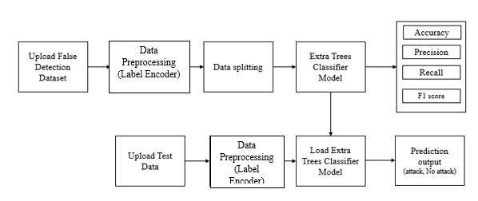
4.1: Blocked Diagram
Step 2 Dataset Preprocessing (Null Value Removal, Label Encoding): Before feeding the dataset into machine learning algorithms, it undergoes preprocessing steps to ensure its quality and compatibility with the models. This includes handling missing or null values by either removing them or imputing them with appropriate values. Additionally, categorical variables may be encoded into numerical format through techniques like label encoding to facilitate model training.
Step 3 Existing Naive Bayes Theorem : An existing machine learning algorithm, such as Naive Bayes, is utilized as a baseline model for fault detection in IoT networks. Naive Bayes is a probabilistic classifier known for its simplicity and efficiency, making it suitable for initial experimentation and comparison with more complex models.
Step 4 Proposed Extra Trees Classifier (ETC): In addition to the baseline model, the research proposes the utilization of an Extra Trees Classifier (ETC) for fault detection in IoT networks. ETC is an ensemble learning technique that constructs multiple decision trees and combines their predictions to improve accuracy and robustness. The inherent randomness in building each tree and selecting split points enhances the model's ability to capture complex patterns and outliers within the dataset.

Step 5: Performance Comparison: Following the training and evaluation of both the Naive Bayes model and the ETC model, a comprehensive performance comparison is conducted. Various metrics such as accuracy, precision, recall, and F1-score are computed to assess the effectiveness of each model in accurately identifying faults and minimizing false positives or false negatives. This step helps determine the relative strengths and weaknesses of the proposed approach compared to the baseline method.
Step 6: Prediction of Output from Test Data with ETC Trained Model: The trained ETC model is applied to unseen test data to predict fault occurrences within IoT networks. This step simulates real-world deployment scenarios where the model is tasked with identifying anomalies and potential security breaches in smart home environments based on incoming network traffic data. The model's predictions are then evaluated against ground truth labels to gauge its performance and reliability in practical settings.
4.2 Data Preprocessing
Data pre-processing is a process of preparing the raw data and making it suitable for a machine learning model. It is the first and crucial step while creating a machine learning model. When creating a machine learning project, it is not always a case that we come across the clean and formatted data. And while doing any operation with data, it is mandatory to clean it and put in a formatted way. So, for this, we use data pre-processing task. A real-world data generally contains noises, missing values, and maybe in an unusable format which cannot be directly used for machine learning models. Data pre-processing is required tasks for cleaning the data and making it suitable for a machine learning model which also increases the accuracy and efficiency of a machine learning model.
- Getting the dataset
- Importing libraries
- Importing datasets
- Finding Missing Data
- Encoding Categorical Data
- Splitting dataset into training and test set
- Feature scaling
- SMOTE Data balancing
4.3 Splitting the Dataset

In machine learning data preprocessing, we divide our dataset into a training set and test set. This is one of the crucial steps of data preprocessing as by doing this, we can enhance the performance of our machine learning model. Suppose if we have given training to our machine learning model by a dataset and we test it by a completely different dataset. Then, it will create difficulties for our model to understand the correlations between the models. If we train our model very well and its training accuracy is also very high, but we provide a new dataset to it, then it will decrease the performance. So we always try to make a machine learning model which performs well with the training set and also with the test dataset. Here, we can define these datasets as:
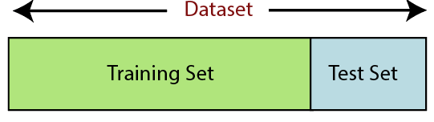
Figure 4.2: Splitting the dataset.
Training Set: A subset of dataset to train the machine learning model, and we already know the output.
Test set: A subset of dataset to test the machine learning model, and by using the test set, model predicts the output.
For splitting the dataset, we will use the below lines of code:
from sklearn.model_selection import train_test_split
x_train, x_test, y_train, y_test= train_test_split(x, y, test_size= 0.2, random_state=0)
Explanation: In the above code, the first line is used for splitting arrays of the dataset into random train and test subsets. In the second line, we have used four variables for our output that are
- x_train: features for the training data
- x_test: features for testing data
- y_train: Dependent variables for training data
- y_test: Independent variable for testing data
In train_test_split() function, we have passed four parameters in which first two are for arrays of data, and test_size is for specifying the size of the test set. The test_size maybe .5, .3, or .2, which tells the dividing ratio of training and testing sets. The last parameter random_state is used to set a seed for a random generator so that you always get the same result, and the most used value for this is 42.
4.4 ETC Classifier
The Extra Trees Classifier (ETC) is a powerful machine learning algorithm that belongs to the ensemble learning family, known for its robustness and efficiency in handling complex classification tasks. With its ability to mitigate overfitting and effectively capture intricate patterns in the data, ETC has gained popularity in various domains, including predictive maintenance, fraud detection, and sentiment analysis. In this detailed operational procedure, we will delve into the inner workings of ETC, covering its key components, training process, and interpretation of results.

Before diving into the specifics of the Extra Trees Classifier, it's essential to understand the broader concept of ensemble learning and decision trees. Ensemble learning involves combining multiple individual models (learners) to improve predictive performance compared to any single model. Decision trees, on the other hand, are hierarchical structures that recursively partition the feature space into regions, making predictions based on simple rules inferred from the data.
4.4.1 Overview of Extra Trees Classifier
The Extra Trees Classifier is an ensemble learning method that builds upon the foundation of decision trees. Unlike traditional decision trees, which select optimal splits based on a certain criterion (e.g., Gini impurity or information gain), ETC introduces randomness into the tree-building process. This randomness is manifested in two key aspects: feature selection and split points.
- Feature Selection: In a standard decision tree, at each node, a subset of features is evaluated to determine the best split. However, ETC takes a different approach by selecting features randomly from the full set of features at each node. This random feature selection helps to decorrelate the trees in the ensemble, reducing the risk of overfitting and enhancing the model's generalization ability.
- Split Points: Similarly, ETC introduces randomness in selecting split points for each feature. Instead of searching for the optimal split point based on a specific criterion (e.g., maximizing information gain), ETC chooses split points randomly within the feature's range. This randomness adds another layer of diversification to the ensemble, making the model more robust to noise and outliers in the data.
- In addition to evaluating the model's overall performance, it's also important to analyze the contribution of individual features to the prediction task. Feature importance scores can be computed based on various criteria, such as the average depth or number of times a feature is selected for splitting across all trees in the ensemble. These feature importance scores provide valuable insights into which features are most informative for making predictions and can help guide feature selection and model interpretation efforts.
4.4.2 Training Process
The training process of the Extra Trees Classifier involves several steps, beginning with the initialization of the ensemble and iteratively growing individual trees. Figure 4.3 shows the ETC model architecture.


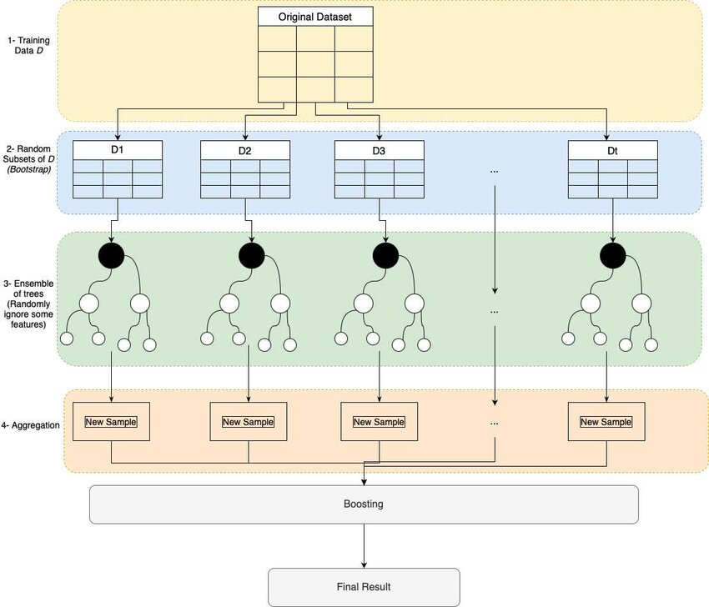
Figure 4.3. ETC Model Architecture.
The detailed operation procedure as follows
Step 1: Ensemble Initialization The training process starts with the initialization of an empty ensemble, which will eventually consist of multiple decision trees. The number of trees in the ensemble, also known as the ensemble size or n_estimators, is a hyperparameter that needs to be specified by the user. Typically, larger ensemble sizes lead to better performance but also increase computational overhead.
Step 2: Tree Growth: For each tree in the ensemble, the following steps are repeated until the tree reaches the maximum allowable depth (max_depth) or another stopping criterion is met:
- Sample Selection: A random subset of the training data is selected with replacement (bootstrap sampling) to create a training subset for the current tree. This process, known as bagging (bootstrap aggregating), introduces diversity into the training process and helps prevent overfitting.
- Feature Selection: At each node of the tree, a random subset of features is selected from the full set of features. The number of features to consider at each split (max_features) is another hyperparameter that can be tuned to control the level of randomness in feature selection.

- Split Point Selection: For each selected feature, a random split point is chosen within the range of feature values in the training subset. The criterion used for split point selection may vary depending on the type of feature (e.g., continuous or categorical), but common approaches include random thresholding for continuous features and random sampling for categorical features.
- Node Splitting: Based on the selected feature and split point, the training subset is partitioned into two child nodes. This process continues recursively until a stopping criterion is reached, such as reaching the maximum tree depth or minimum samples per leaf.
Step 3: Ensemble Aggregation: Once all trees in the ensemble have been grown, predictions are made by aggregating the outputs of individual trees. For classification tasks, the most common aggregation method is a majority vote, where the class with the most votes across all trees is selected as the final prediction. For regression tasks, predictions are typically averaged across all trees to obtain the final output.
Step 4: Interpretation of Results: After training the Extra Trees Classifier on the training data, the model's performance needs to be evaluated on unseen test data to assess its predictive accuracy and generalization ability. Common evaluation metrics for classification tasks include accuracy, precision, recall, F1-score, and area under the receiver operating characteristic curve (ROC AUC).

CHAPTER 5
UML DIAGRAMS


UML stands for Unified Modeling Language. UML is a standardized general-purpose modeling language in the field of object-oriented software engineering. The standard is managed, and was created by, the Object Management Group. The goal is for UML to become a common language for creating models of object-oriented computer software. In its current form UML is comprised of two major components: a Meta-model and a notation. In the future, some form of method or process may also be added to; or associated with, UML.
The Unified Modeling Language is a standard language for specifying, Visualization, Constructing and documenting the artifacts of software system, as well as for business modeling and other non-software systems. The UML represents a collection of best engineering practices that have proven successful in the modeling of large and complex systems. The UML is a very important part of developing objects-oriented software and the software development process. The UML uses mostly graphical notations to express the design of software projects.
GOALS: The Primary goals in the design of the UML are as follows:
- Provide users a ready-to-use, expressive visual modeling Language so that they can develop and exchange meaningful models.
- Provide extendibility and specialization mechanisms to extend the core concepts.
- Be independent of particular programming languages and development process.
- Provide a formal basis for understanding the modeling language.
- Encourage the growth of OO tools market.
- Support higher level development concepts such as collaborations, frameworks, patterns and components.
- Integrate best practices.

Class Diagram
The class diagram is used to refine the use case diagram and define a detailed design of the system. The class diagram classifies the actors defined in the use case diagram into a set of interrelated classes. The relationship or association between the classes can be either an “is-a” or “has-a” relationship. Each class in the class diagram may be capable of providing certain functionalities. These functionalities provided by the class are termed “methods” of the class. Apart from this, each class may have certain “attributes” that uniquely identify the class.

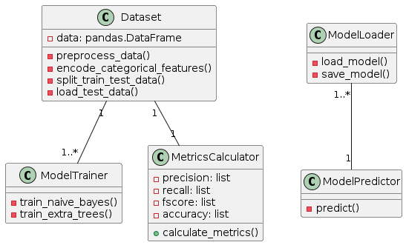
Sequence Diagram
A sequence diagram in Unified Modeling Language (UML) is a kind of interaction diagram that shows how processes operate with one another and in what order. It is a construct of a Message Sequence Chart. A sequence diagram shows, as parallel vertical lines (“lifelines”), different processes or objects that live simultaneously, and as horizontal arrows, the messages exchanged between them, in the order in which they occur. This allows the specification of simple runtime scenarios in a graphical manner.

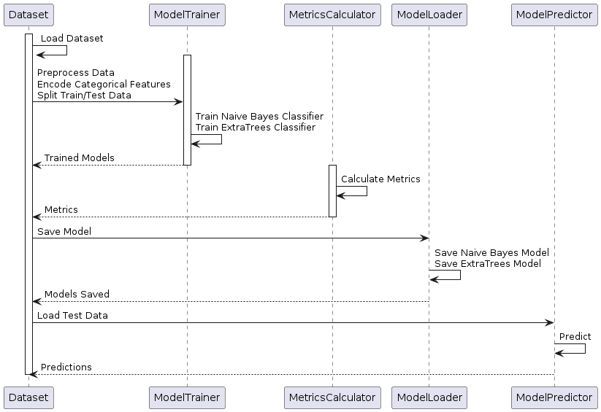

Activity diagram: Activity diagram is another important diagram in UML to describe the dynamic aspects of the system.

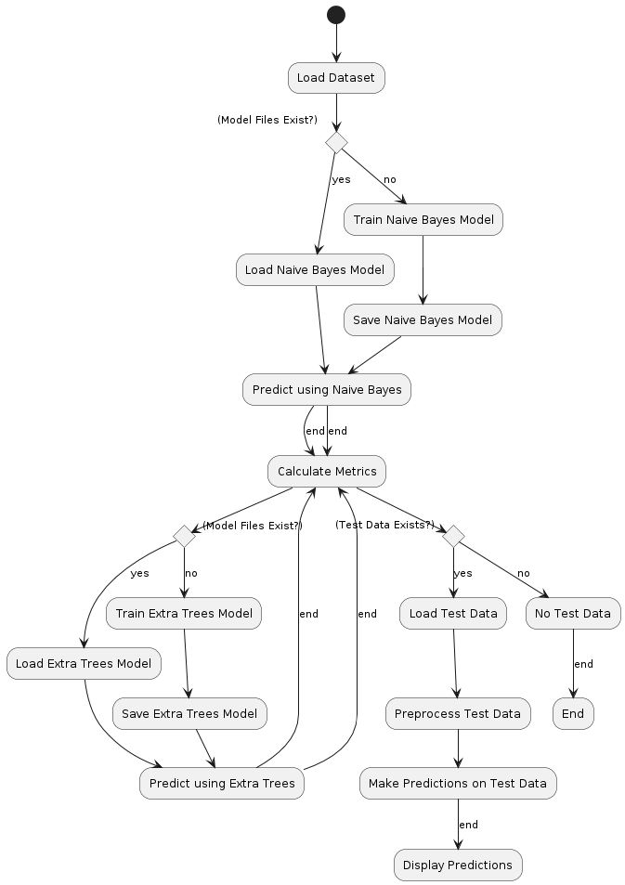
Deployment diagram
A deployment diagram in the Unified Modeling Language models the physical deployment of artifacts on nodes. To describe a web site, for example, a deployment diagram would show what hardware components (“nodes”) exist (e.g., a web server, an application server, and a database server), what software components (“artifacts”) run on each node (e.g., web application, database), and how the different pieces are connected (e.g., JDBC, REST, RMI). The nodes appear as boxes, and the artifacts allocated to each node appear as rectangles within the boxes. Nodes may have sub nodes, which appear as nested boxes. A single node in a deployment diagram may conceptually represent multiple physical nodes, such as a cluster of database servers.
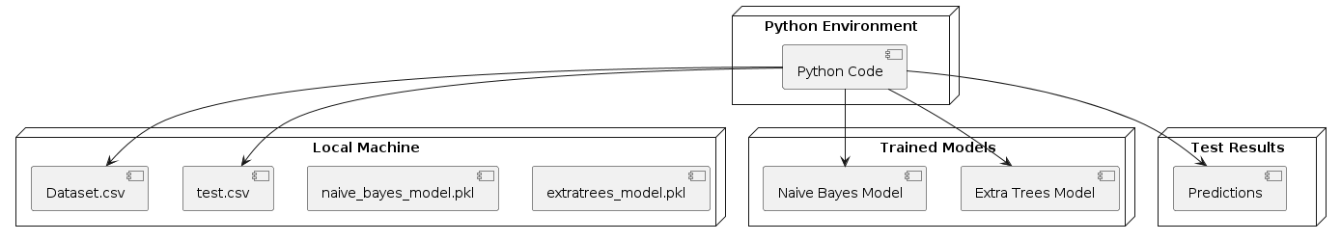

Use case diagram

A use case diagram in the Unified Modeling Language (UML) is a type of behavioral diagram defined by and created from a Use-case analysis. Its purpose is to present a graphical overview of the functionality provided by a system in terms of actors, their goals (represented as use cases), and any dependencies between those use cases. The main purpose of a use case diagram is to show what system functions are performed for which actor. Roles of the actors in the system can be depicted.

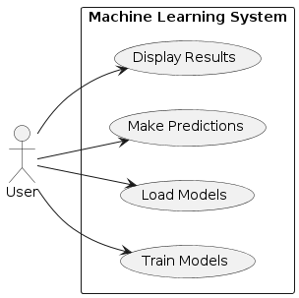
Component diagram: Component diagram describes the organization and wiring of the physical components in a system.

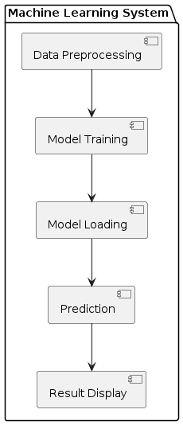
Data Flow Diagram (DFD):
In UML (Unified Modeling Language) is a graphical representation of the flow of data through a system. It's particularly useful for understanding the data inputs, outputs, processes, and storage within a system or software application. Here's
External Entities: These are entities outside the system that interact with it, such as users, other systems, or databases. They are represented as rectangles on the edges of the diagram.
Processes: Processes represent the actions or transformations that occur within the system. They are depicted as circles or ovals and typically have labels describing the action they perform on the data.
Data Stores: Data stores represent where data is stored within the system. They can be databases, files, or any other storage medium. Data stores are typically represented as rectangles.
Data Flows: Data flows represent the movement of data between external entities, processes, and data stores. They are depicted as arrows and indicate the direction of data flow.
Data Transformations: These represent the conversion or manipulation of data within a process. They can be depicted using labels on the data flow arrows or as separate process symbols.

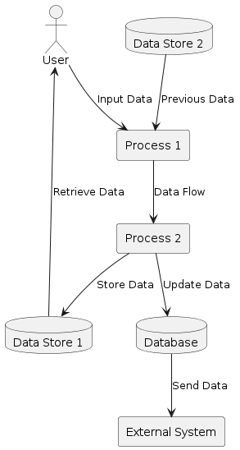

CHAPTER 6
SOFTWARE ENVIRONMENT
What is Python?
Below are some facts about Python.
- Python is currently the most widely used multi-purpose, high-level programming language.

- Python allows programming in Object-Oriented and Procedural paradigms. Python programs generally are smaller than other programming languages like Java.
- Programmers have to type relatively less and indentation requirement of the language, makes them readable all the time.
- Python language is being used by almost all tech-giant companies like – Google, Amazon, Facebook, Instagram, Dropbox, Uber… etc.
The biggest strength of Python is huge collection of standard library which can be used for the following –
- Machine Learning
- GUI Applications (like Kivy, Tkinter, PyQt etc. )
- Web frameworks like Django (used by YouTube, Instagram, Dropbox)
- Image processing (like Opencv, Pillow)
- Web scraping (like Scrapy, BeautifulSoup, Selenium)
- Test frameworks
- Multimedia
Advantages of Python
Let’s see how Python dominates over other languages.
1. Extensive Libraries
Python downloads with an extensive library and it contain code for various purposes like regular expressions, documentation-generation, unit-testing, web browsers, threading, databases, CGI, email, image manipulation, and more. So, we don’t have to write the complete code for that manually.
2. Extensible
As we have seen earlier, Python can be extended to other languages. You can write some of your code in languages like C++ or C. This comes in handy, especially in projects.
3. Embeddable
Complimentary to extensibility, Python is embeddable as well. You can put your Python code in your source code of a different language, like C++. This lets us add scripting capabilities to our code in the other language.
4. Improved Productivity
The language’s simplicity and extensive libraries render programmers more productive than languages like Java and C++ do. Also, the fact that you need to write less and get more things done.
5. IOT Opportunities

Since Python forms the basis of new platforms like Raspberry Pi, it finds the future bright for the Internet Of Things. This is a way to connect the language with the real world.
6. Simple and Easy
When working with Java, you may have to create a class to print ‘Hello World’. But in Python, just a print statement will do. It is also quite easy to learn, understand, and code. This is why when people pick up Python, they have a hard time adjusting to other more verbose languages like Java.
7. Readable
Because it is not such a verbose language, reading Python is much like reading English. This is the reason why it is so easy to learn, understand, and code. It also does not need curly braces to define blocks, and indentation is mandatory. This further aids the readability of the code.
8. Object-Oriented
This language supports both the procedural and object-oriented programming paradigms. While functions help us with code reusability, classes and objects let us model the real world. A class allows the encapsulation of data and functions into one.
9. Free and Open-Source
Like we said earlier, Python is freely available. But not only can you download Python for free, but you can also download its source code, make changes to it, and even distribute it. It downloads with an extensive collection of libraries to help you with your tasks.
10. Portable
When you code your project in a language like C++, you may need to make some changes to it if you want to run it on another platform. But it isn’t the same with Python. Here, you need to code only once, and you can run it anywhere. This is called Write Once Run Anywhere (WORA). However, you need to be careful enough not to include any system-dependent features.
11. Interpreted
Lastly, we will say that it is an interpreted language. Since statements are executed one by one, debugging is easier than in compiled languages.
Any doubts till now in the advantages of Python? Mention in the comment section.
Advantages of Python Over Other Languages
1. Less Coding
Almost all of the tasks done in Python requires less coding when the same task is done in other languages. Python also has an awesome standard library support, so you don’t have to search for any third-party libraries to get your job done. This is the reason that many people suggest learning Python to beginners.

2. Affordable
Python is free therefore individuals, small companies or big organizations can leverage the free available resources to build applications. Python is popular and widely used so it gives you better community support.
The 2019 Github annual survey showed us that Python has overtaken Java in the most popular programming language category.
3. Python is for Everyone
Python code can run on any machine whether it is Linux, Mac or Windows. Programmers need to learn different languages for different jobs but with Python, you can professionally build web apps, perform data analysis and machine learning, automate things, do web scraping and also build games and powerful visualizations. It is an all-rounder programming language.
Disadvantages of Python
So far, we’ve seen why Python is a great choice for your project. But if you choose it, you should be aware of its consequences as well. Let’s now see the downsides of choosing Python over another language.
1. Speed Limitations
We have seen that Python code is executed line by line. But since Python is interpreted, it often results in slow execution. This, however, isn’t a problem unless speed is a focal point for the project. In other words, unless high speed is a requirement, the benefits offered by Python are enough to distract us from its speed limitations.
2. Weak in Mobile Computing and Browsers
While it serves as an excellent server-side language, Python is much rarely seen on the client-side. Besides that, it is rarely ever used to implement smartphone-based applications. One such application is called Carbonnelle.
The reason it is not so famous despite the existence of Brython is that it isn’t that secure.
3. Design Restrictions
As you know, Python is dynamically-typed. This means that you don’t need to declare the type of variable while writing the code. It uses duck-typing. But wait, what’s that? Well, it just means that if it looks like a duck, it must be a duck. While this is easy on the programmers during coding, it can raise run-time errors.
4. Underdeveloped Database Access Layers

Compared to more widely used technologies like JDBC (Java DataBase Connectivity) and ODBC (Open DataBase Connectivity), Python’s database access layers are a bit underdeveloped. Consequently, it is less often applied in huge enterprises.
5. Simple
No, we’re not kidding. Python’s simplicity can indeed be a problem. Take my example. I don’t do Java, I’m more of a Python person. To me, its syntax is so simple that the verbosity of Java code seems unnecessary.
This was all about the Advantages and Disadvantages of Python Programming Language.
History of Python
What do the alphabet and the programming language Python have in common? Right, both start with ABC. If we are talking about ABC in the Python context, it's clear that the programming language ABC is meant. ABC is a general-purpose programming language and programming environment, which had been developed in the Netherlands, Amsterdam, at the CWI (Centrum Wiskunde &Informatica). The greatest achievement of ABC was to influence the design of Python. Python was conceptualized in the late 1980s. Guido van Rossum worked that time in a project at the CWI, called Amoeba, a distributed operating system. In an interview with Bill Venners1, Guido van Rossum said: "In the early 1980s, I worked as an implementer on a team building a language called ABC at Centrum voor Wiskunde en Informatica (CWI). I don't know how well people know ABC's influence on Python. I try to mention ABC's influence because I'm indebted to everything I learned during that project and to the people who worked on it. "Later on in the same Interview, Guido van Rossum continued: "I remembered all my experience and some of my frustration with ABC. I decided to try to design a simple scripting language that possessed some of ABC's better properties, but without its problems. So I started typing. I created a simple virtual machine, a simple parser, and a simple runtime. I made my own version of the various ABC parts that I liked. I created a basic syntax, used indentation for statement grouping instead of curly braces or begin-end blocks, and developed a small number of powerful data types: a hash table (or dictionary, as we call it), a list, strings, and numbers."

Python Development Steps
Guido Van Rossum published the first version of Python code (version 0.9.0) at alt.sources in February 1991. This release included already exception handling, functions, and the core data types of list, dict, str and others. It was also object oriented and had a module system.

Python version 1.0 was released in January 1994. The major new features included in this release were the functional programming tools lambda, map, filter and reduce, which Guido Van Rossum never liked. Six and a half years later in October 2000, Python 2.0 was introduced. This release included list comprehensions, a full garbage collector and it was supporting unicode. Python flourished for another 8 years in the versions 2.x before the next major release as Python 3.0 (also known as "Python 3000" and "Py3K") was released. Python 3 is not backwards compatible with Python 2.x. The emphasis in Python 3 had been on the removal of duplicate programming constructs and modules, thus fulfilling or coming close to fulfilling the 13th law of the Zen of Python: "There should be one -- and preferably only one -- obvious way to do it."Some changes in Python 7.3:
Print is now a function.
- Views and iterators instead of lists
- The rules for ordering comparisons have been simplified. E.g., a heterogeneous list cannot be sorted, because all the elements of a list must be comparable to each other.
- There is only one integer type left, i.e., int. long is int as well.
- The division of two integers returns a float instead of an integer. "//" can be used to have the "old" behaviour.
- Text Vs. Data Instead of Unicode Vs. 8-bit
Purpose
We demonstrated that our approach enables successful segmentation of intra-retinal layers—even with low-quality images containing speckle noise, low contrast, and different intensity ranges throughout—with the assistance of the ANIS feature.
Python
Python is an interpreted high-level programming language for general-purpose programming. Created by Guido van Rossum and first released in 1991, Python has a design philosophy that emphasizes code readability, notably using significant whitespace.
Python features a dynamic type system and automatic memory management. It supports multiple programming paradigms, including object-oriented, imperative, functional and procedural, and has a large and comprehensive standard library.
- Python is Interpreted − Python is processed at runtime by the interpreter. You do not need to compile your program before executing it. This is similar to PERL and PHP.
- Python is Interactive − you can actually sit at a Python prompt and interact with the interpreter directly to write your programs.
Python also acknowledges that speed of development is important. Readable and terse code is part of this, and so is access to powerful constructs that avoid tedious repetition of code. Maintainability also ties into this may be an all but useless metric, but it does say something about how much code you have to scan, read and/or understand to troubleshoot problems or tweak behaviors. This speed of development, the ease with which a programmer of other languages can pick up basic Python skills and the huge standard library is key to another area where Python excels. All its tools have been quick to implement, saved a lot of time, and several of them have later been patched and updated by people with no Python background - without breaking.

Modules Used in Project
NumPy
NumPy is a general-purpose array-processing package. It provides a high-performance multidimensional array object, and tools for working with these arrays.
It is the fundamental package for scientific computing with Python. It contains various features including these important ones:
- A powerful N-dimensional array object
- Sophisticated (broadcasting) functions
- Tools for integrating C/C++ and Fortran code
- Useful linear algebra, Fourier transform, and random number capabilities
Besides its obvious scientific uses, NumPy can also be used as an efficient multi-dimensional container of generic data. Arbitrary datatypes can be defined using NumPy which allows NumPy to seamlessly and speedily integrate with a wide variety of databases.
Pandas
Pandas is an open-source Python Library providing high-performance data manipulation and analysis tool using its powerful data structures. Python was majorly used for data munging and preparation. It had very little contribution towards data analysis. Pandas solved this problem. Using Pandas, we can accomplish five typical steps in the processing and analysis of data, regardless of the origin of data load, prepare, manipulate, model, and analyze. Python with Pandas is used in a wide range of fields including academic and commercial domains including finance, economics, Statistics, analytics, etc.
Matplotlib
Matplotlib is a Python 2D plotting library which produces publication quality figures in a variety of hardcopy formats and interactive environments across platforms. Matplotlib can be used in Python scripts, the Python and IPython shells, the Jupyter Notebook, web application servers, and four graphical user interface toolkits. Matplotlib tries to make easy things easy and hard things possible. You can generate plots, histograms, power spectra, bar charts, error charts, scatter plots, etc., with just a few lines of code. For examples, see the sample plots and thumbnail gallery.
For simple plotting the pyplot module provides a MATLAB-like interface, particularly when combined with IPython. For the power user, you have full control of line styles, font properties, axes properties, etc, via an object oriented interface or via a set of functions familiar to MATLAB users.
Scikit – learn

Scikit-learn provides a range of supervised and unsupervised learning algorithms via a consistent interface in Python. It is licensed under a permissive simplified BSD license and is distributed under many Linux distributions, encouraging academic and commercial use. Python
Python is an interpreted high-level programming language for general-purpose programming. Created by Guido van Rossum and first released in 1991, Python has a design philosophy that emphasizes code readability, notably using significant whitespace.
Python features a dynamic type system and automatic memory management. It supports multiple programming paradigms, including object-oriented, imperative, functional and procedural, and has a large and comprehensive standard library.
- Python is Interpreted − Python is processed at runtime by the interpreter. You do not need to compile your program before executing it. This is similar to PERL and PHP.
- Python is Interactive − you can actually sit at a Python prompt and interact with the interpreter directly to write your programs.
Python also acknowledges that speed of development is important. Readable and terse code is part of this, and so is access to powerful constructs that avoid tedious repetition of code. Maintainability also ties into this may be an all but useless metric, but it does say something about how much code you have to scan, read and/or understand to troubleshoot problems or tweak behaviors. This speed of development, the ease with which a programmer of other languages can pick up basic Python skills and the huge standard library is key to another area where Python excels. All its tools have been quick to implement, saved a lot of time, and several of them have later been patched and updated by people with no Python background - without breaking.
Install Python Step-by-Step in Windows and Mac
Python a versatile programming language doesn’t come pre-installed on your computer devices. Python was first released in the year 1991 and until today it is a very popular high-level programming language. Its style philosophy emphasizes code readability with its notable use of great whitespace.
The object-oriented approach and language construct provided by Python enables programmers to write both clear and logical code for projects. This software does not come pre-packaged with Windows.
How to Install Python on Windows and Mac
There have been several updates in the Python version over the years. The question is how to install Python? It might be confusing for the beginner who is willing to start learning Python but this tutorial will solve your query. The latest or the newest version of Python is version 3.7.4 or in other words, it is Python 3.
Note: The python version 3.7.4 cannot be used on Windows XP or earlier devices.

Before you start with the installation process of Python. First, you need to know about your System Requirements. Based on your system type i.e. operating system and based processor, you must download the python version. My system type is a Windows 64-bit operating system. So the steps below are to install python version 3.7.4 on Windows 7 device or to install Python 3. Download the Python Cheatsheet here.The steps on how to install Python on Windows 10, 8 and 7 are divided into 4 parts to help understand better.
Download the Correct version into the system
Step 1: Go to the official site to download and install python using Google Chrome or any other web browser. OR Click on the following link: https://www.python.org
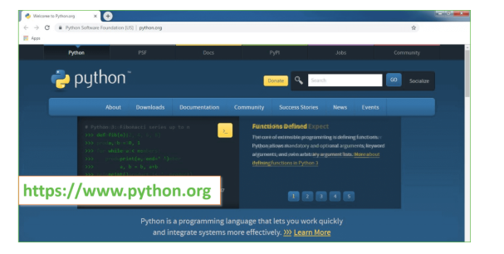
Now, check for the latest and the correct version for your operating system.
Step 2: Click on the Download Tab.

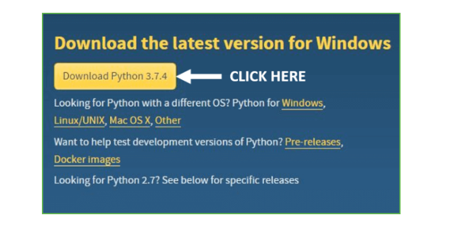
Step 3: You can either select the Download Python for windows 3.7.4 button in Yellow Color or you can scroll further down and click on download with respective to their version. Here, we are downloading the most recent python version for windows 3.7.4
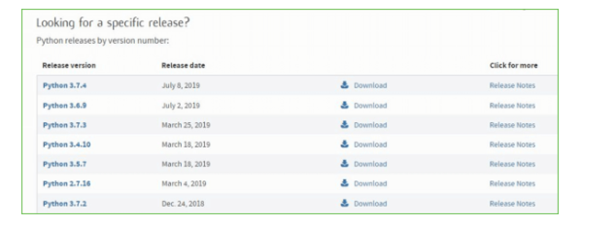
Step 4: Scroll down the page until you find the Files option.
Step 5: Here you see a different version of python along with the operating system.
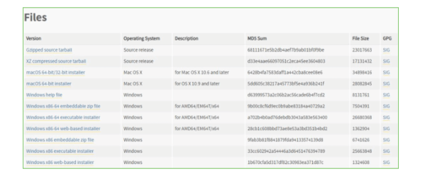
- To download Windows 32-bit python, you can select any one from the three options: Windows x86 embeddable zip file, Windows x86 executable installer or Windows x86 web-based installer.

- To download Windows 64-bit python, you can select any one from the three options: Windows x86-64 embeddable zip file, Windows x86-64 executable installer or Windows x86-64 web-based installer.
Here we will install Windows x86-64 web-based installer. Here your first part regarding which version of python is to be downloaded is completed. Now we move ahead with the second part in installing python i.e. Installation
Note: To know the changes or updates that are made in the version you can click on the Release Note Option.
Installation of Python
Step 1: Go to Download and Open the downloaded python version to carry out the installation process.
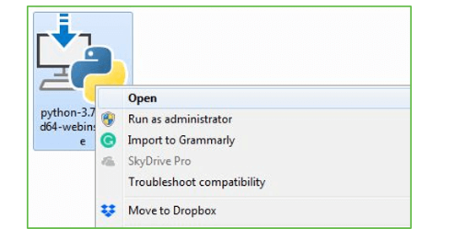

Step 2: Before you click on Install Now, Make sure to put a tick on Add Python 3.7 to PATH.
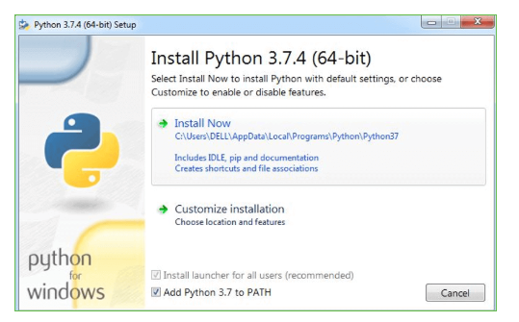
Step 3: Click on Install NOW After the installation is successful. Click on Close.


With these above three steps on python installation, you have successfully and correctly installed Python. Now is the time to verify the installation.
Note: The installation process might take a couple of minutes.
Verify the Python Installation
Step 1: Click on Start
Step 2: In the Windows Run Command, type “cmd”.
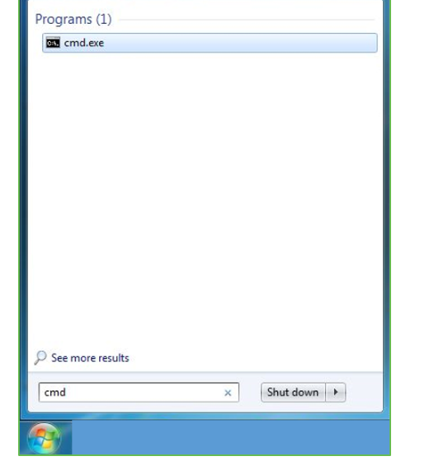
Step 3: Open the Command prompt option.
Step 4: Let us test whether the python is correctly installed. Type python –V and press Enter.

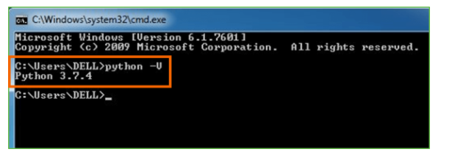
Step 5: You will get the answer as 3.7.4
Note: If you have any of the earlier versions of Python already installed. You must first uninstall the earlier version and then install the new one.
Check how the Python IDLE works
Step 1: Click on Start
Step 2: In the Windows Run command, type “python idle”.
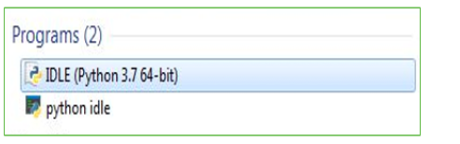
Step 3: Click on IDLE (Python 3.7 64-bit) and launch the program
Step 4: To go ahead with working in IDLE you must first save the file. Click on File > Click on Save
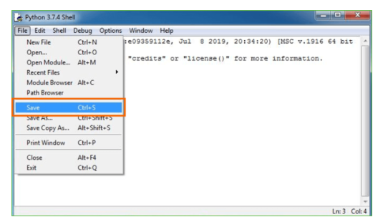

Step 5: Name the file and save as type should be Python files. Click on SAVE. Here I have named the files as Hey World.
Step 6: Now for e.g. enter print (“Hey World”) and Press Enter.
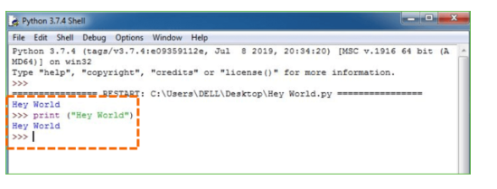
You will see that the command given is launched. With this, we end our tutorial on how to install Python. You have learned how to download python for windows into your respective operating system.
Note: Unlike Java, Python does not need semicolons at the end of the statements otherwise it won’t work.

CHAPTER 7
SYSTEM REQUIREMENTS
SOFTWARE REQUIREMENTS

The functional requirements or the overall description documents include the product perspective and features, operating system and operating environment, graphics requirements, design constraints and user documentation.
The appropriation of requirements and implementation constraints gives the general overview of the project in regard to what the areas of strength and deficit are and how to tackle them.
- Python IDLE 3.7 version (or)
- Anaconda 3.7 (or)
- Jupiter (or)
- Google colab
HARDWARE REQUIREMENTS
Minimum hardware requirements are very dependent on the particular software being developed by a given Enthought Python / Canopy / VS Code user. Applications that need to store large arrays/objects in memory will require more RAM, whereas applications that need to perform numerous calculations or tasks more quickly will require a faster processor.
- Operating system : Windows, Linux
- Processor : minimum intel i3
- Ram : minimum 4 GB
- Hard disk : minimum 250GB

CHAPTER 8
FUNCTIONAL REQUIREMENTS
OUTPUT DESIGN

Outputs from computer systems are required primarily to communicate the results of processing to users. They are also used to provides a permanent copy of the results for later consultation. The various types of outputs in general are:
- External Outputs, whose destination is outside the organization
- Internal Outputs whose destination is within organization and they are the
- User’s main interface with the computer.
- Operational outputs whose use is purely within the computer department.
- Interface outputs, which involve the user in communicating directly.
OUTPUT DEFINITION
The outputs should be defined in terms of the following points:
- Type of the output
- Content of the output
- Format of the output
- Location of the output
- Frequency of the output
- Volume of the output
- Sequence of the output
It is not always desirable to print or display data as it is held on a computer. It should be decided as which form of the output is the most suitable.
INPUT DESIGN
Input design is a part of overall system design. The main objective during the input design is as given below:
- To produce a cost-effective method of input.
- To achieve the highest possible level of accuracy.
- To ensure that the input is acceptable and understood by the user.
INPUT STAGES
The main input stages can be listed as below:
- Data recording
- Data transcription
- Data conversion
- Data verification
- Data control

- Data transmission
- Data validation
- Data correction
INPUT TYPES
It is necessary to determine the various types of inputs. Inputs can be categorized as follows:
- External inputs, which are prime inputs for the system.
- Internal inputs, which are user communications with the system.
- Operational, which are computer department’s communications to the system?
- Interactive, which are inputs entered during a dialogue.
INPUT MEDIA
At this stage choice has to be made about the input media. To conclude about the input media consideration has to be given to;
- Type of input
- Flexibility of format
- Speed
- Accuracy
- Verification methods
- Rejection rates
- Ease of correction
- Storage and handling requirements
- Security
- Easy to use
- Portability
Keeping in view the above description of the input types and input media, it can be said that most of the inputs are of the form of internal and interactive. As
Input data is to be the directly keyed in by the user, the keyboard can be considered to be the most suitable input device.

ERROR AVOIDANCE
At this stage care is to be taken to ensure that input data remains accurate form the stage at which it is recorded up to the stage in which the data is accepted by the system. This can be achieved only by means of careful control each time the data is handled.
ERROR DETECTION
Even though every effort is make to avoid the occurrence of errors, still a small proportion of errors is always likely to occur, these types of errors can be discovered by using validations to check the input data.

DATA VALIDATION
Procedures are designed to detect errors in data at a lower level of detail. Data validations have been included in the system in almost every area where there is a possibility for the user to commit errors. The system will not accept invalid data. Whenever an invalid data is keyed in, the system immediately prompts the user and the user has to again key in the data and the system will accept the data only if the data is correct. Validations have been included where necessary.
The system is designed to be a user friendly one. In other words the system has been designed to communicate effectively with the user. The system has been designed with popup menus.
USER INTERFACE DESIGN
It is essential to consult the system users and discuss their needs while designing the user interface:USER INTERFACE SYSTEMS CAN BE BROADLY CLASIFIED AS:
- User initiated interface the user is in charge, controlling the progress of the user/computer dialogue. In the computer-initiated interface, the computer selects the next stage in the interaction.
- Computer initiated interfaces
In the computer-initiated interfaces the computer guides the progress of the user/computer dialogue. Information is displayed and the user response of the computer takes action or displays further information.

USER INITIATED INTERGFACES
User initiated interfaces fall into two approximate classes:
- Command driven interfaces: In this type of interface the user inputs commands or queries which are interpreted by the computer.
- Forms oriented interface: The user calls up an image of the form to his/her screen and fills in the form. The forms-oriented interface is chosen because it is the best choice.
COMPUTER-INITIATED INTERFACES
The following computer – initiated interfaces were used:
- The menu system for the user is presented with a list of alternatives and the user chooses one; of alternatives.
- Questions – answer type dialog system where the computer asks question and takes action based on the basis of the users reply.

Right from the start the system is going to be menu driven, the opening menu displays the available options. Choosing one option gives another popup menu with more options. In this way every option leads the users to data entry form where the user can key in the data.
ERROR MESSAGE DESIGN
The design of error messages is an important part of the user interface design. As user is bound to commit some errors or other while designing a system the system should be designed to be helpful by providing the user with information regarding the error he/she has committed.
This application must be able to produce output at different modules for different inputs.
PERFORMANCE REQUIREMENTS
Performance is measured in terms of the output provided by the application. Requirement specification plays an important part in the analysis of a system. Only when the requirement specifications are properly given, it is possible to design a system, which will fit into required environment. It rests largely in the part of the users of the existing system to give the requirement specifications because they are the people who finally use the system. This is because the requirements have to be known during the initial stages so that the system can be designed according to those requirements. It is very difficult to change the system once it has been designed and on the other hand designing a system, which does not cater to the requirements of the user, is of no use.
The requirement specification for any system can be broadly stated as given below:
- The system should be able to interface with the existing system
- The system should be accurate
- The system should be better than the existing system
- The existing system is completely dependent on the user to perform all the duties

CHAPTER 9
SOURCE CODE
import pandas as pd
import numpy as np
import matplotlib.pyplot as plt

import seaborn as sns
from sklearn.preprocessing import LabelEncoder
from imblearn.over_sampling import SMOTE
from sklearn.model_selection import train_test_split
from sklearn.feature_selection import SelectKBest
from sklearn.feature_selection import f_classif
from sklearn.ensemble import ExtraTreesClassifier
from sklearn.naive_bayes import GaussianNB
import joblib
import os
from sklearn.metrics import precision_score
from sklearn.metrics import recall_score
from sklearn.metrics import f1_score
from sklearn.metrics import accuracy_score,confusion_matrix,classification_report
dataset=pd.read_csv("Dataset.csv")
dataset.isnull().sum()
# Create a count plot
sns.set(style="darkgrid") # Set the style of the plot
plt.figure(figsize=(8, 6)) # Set the figure size
# Replace 'dataset' with your actual DataFrame and 'Drug' with the column name
ax = sns.countplot(x='attack', data=dataset, palette="Set3")
plt.title("Count Plot") # Add a title to the plot
plt.xlabel("Categories") # Add label to x-axis
plt.ylabel("Count") # Add label to y-axis
# Annotate each bar with its count value
for p in ax.patches:
ax.annotate(f'{p.get_height()}', (p.get_x() + p.get_width() / 2., p.get_height()),
ha='center', va='center', fontsize=10, color='black', xytext=(0, 5),
textcoords='offset points')

plt.show() # Display the plot
le= LabelEncoder()
dataset['attack']= le.fit_transform(dataset['attack'])

dataset['protocol_type']= le.fit_transform(dataset['protocol_type'])
dataset['service']= le.fit_transform(dataset['service'])
dataset['flag']= le.fit_transform(dataset['flag'])
X=dataset.iloc[:,0:23]
y=dataset.iloc[:,-1]
X_train,X_test,y_train,y_test= train_test_split(X,y,test_size=0.20)
labels=['Attack','NORMAL']
#defining global variables to store accuracy and other metrics
precision = []
recall = []
fscore = []
accuracy = []
#function to calculate various metrics such as accuracy, precision etc
def calculateMetrics(algorithm, predict, testY):
testY = testY.astype('int')
predict = predict.astype('int')
p = precision_score(testY, predict,average='macro') * 100
r = recall_score(testY, predict,average='macro') * 100
f = f1_score(testY, predict,average='macro') * 100
a = accuracy_score(testY,predict)*100
accuracy.append(a)
precision.append(p)
recall.append(r)
fscore.append(f)
print(algorithm+' Accuracy : '+str(a))
print(algorithm+' Precision : '+str(p))
print(algorithm+' Recall : '+str(r))
print(algorithm+' FSCORE : '+str(f))
report=classification_report(predict, testY,target_names=labels)
print('\n',algorithm+" classification report\n",report)
conf_matrix = confusion_matrix(testY, predict)
plt.figure(figsize =(5, 5))
ax = sns.heatmap(conf_matrix, xticklabels = labels, yticklabels = labels, annot = True, cmap="Blues" ,fmt ="g");

ax.set_ylim([0,len(labels)])
plt.title(algorithm+" Confusion matrix")
plt.ylabel('True class')
plt.xlabel('Predicted class')
plt.show()
if os.path.exists('naive_bayes_model.pkl'):
# Load the trained model from the file
clf = joblib.load('naive_bayes_model.pkl')
print("Model loaded successfully.")
predict = clf.predict(X_test)
calculateMetrics("Naive Bayes Classifier", predict, y_test)
else:
# Train the model (assuming X_train and y_train are defined)
clf = GaussianNB()
clf.fit(X_train, y_train)
# Save the trained model to a file
joblib.dump(clf, 'naive_bayes_model.pkl')
print("Model saved successfully.")
predict = clf.predict(X_test)
calculateMetrics("Naive Bayes Classifier", predict, y_test)
# Check if the model files exist
if os.path.exists('extratrees_model.pkl'):
# Load the trained model from the file
clf = joblib.load('extratrees_model.pkl')
print("Model loaded successfully.")
predict = clf.predict(X_test)
calculateMetrics("ExtraTreesClassifier", predict, y_test)
else:
# Train the model (assuming X_train and y_train are defined)
clf = ExtraTreesClassifier()
clf.fit(X_train, y_train)
# Save the trained model to a file
joblib.dump(clf, 'extratrees_model.pkl')

print("Model saved successfuly.")
predict = clf.predict(X_test)
calculateMetrics("ExtraTreesClassifier", predict, y_test)
#showing all algorithms performance values
columns = ["Algorithm Name","Precison","Recall","FScore","Accuracy"]
values = []
algorithm_names = ["Naive Bayes Classifier", "ExtraTreesClassifier"]
for i in range(len(algorithm_names)):
values.append([algorithm_names[i],precision[i],recall[i],fscore[i],accuracy[i]])

temp = pd.DataFrame(values,columns=columns)
temp
dataset=pd.read_csv("test.csv")
dataset['protocol_type']= le.fit_transform(dataset['protocol_type'])
dataset['service']= le.fit_transform(dataset['service'])
dataset['flag']= le.fit_transform(dataset['flag'])

# Make predictions on the selected test data
predict = clf.predict(dataset)

# Loop through each prediction and print the corresponding row
for i, p in enumerate(predict):
if p == 0:
print(dataset.iloc[i]) # Print the row where prediction is failure
print("Row {}:************************************************** Attack".format(i))

else:
print(dataset.iloc[i]) # Print the row where prediction is no failure
print("Row {}:************************************************** NORMAL".format(i))

dataset['Predicted']=predict
CHAPTER 10
RESULTS AND DISCUSSION

10.1 Implementation Description

The abstract outlines the significance of employing machine learning techniques for fault detection in IoT-based smart homes, emphasizing the bolstering of cybersecurity and safeguarding of user privacy. By accurately identifying and mitigating potential faults, these systems not only protect personal data and physical assets from unauthorized access but also enhance the overall resilience of smart home ecosystems, ensuring uninterrupted functionality and fostering user trust in IoT technologies.
To implement the proposed solution, Python libraries such as pandas, numpy, and scikit-learn are utilized. The process begins with data preprocessing, including handling missing values and encoding categorical features using LabelEncoder. The dataset is then split into training and testing sets for model evaluation. Visualizations, like count plots, provide insights into the distribution of classes within the dataset.
Two machine learning algorithms, Naive Bayes Classifier and ExtraTreesClassifier, are employed for fault detection. Model training involves fitting the algorithms to the training data, followed by evaluation on the testing set. Metrics such as accuracy, precision, recall, and F1-score are calculated to assess model performance. Confusion matrices and classification reports offer detailed insights into the models' predictive capabilities.
, the implementation includes model persistence, where trained models are saved to disk using joblib for future use, eliminating the need for retraining. The saved models are then loaded for prediction on new data, showcasing the seamless integration of trained models into real-world applications.
The implementation extends to making predictions on new data. The trained models are used to predict whether each instance in the test dataset represents a normal operation or an attack. The predictions are then printed alongside the corresponding data rows, enabling easy identification and classification of potential security threats. The implementation demonstrates a comprehensive approach to leveraging machine learning for fault detection in IoT networks, ensuring robust cybersecurity measures and enhancing user confidence in smart home technologies.

10.2 Dataset Description
The dataset contains information relevant to intelligent home security, focusing on machine learning techniques for fault detection in IoT networks. It comprises various features that encapsulate network traffic attributes and communication protocols within a smart home environment, facilitating the identification of anomalous behaviors or potential security threats.
The dataset includes the following features:
1. Duration: The duration of the connection or communication session.
2. Protocol_type: The communication protocol used, such as TCP or UDP.
3. Service: The type of service or application involved in the communication.

4. Flag: Flags indicating the status of the connection, such as "SF" (successful connection) or "REJ" (rejected connection).
5. Src_bytes: The number of bytes sent from the source to the destination.
6. Dst_bytes: The number of bytes received at the destination.
7. Land: Indicates whether the connection is from/to the same host/port (1 if connection is from/to the same host/port, 0 otherwise).
8. Wrong_fragment: The number of "wrong" fragments in the packet.
9. Urgent: The number of urgent packets.
10. Hot: The number of "hot" indicators.
11. Logged_in: Indicates whether the user is logged in (1 if logged in, 0 otherwise).
12. Num_compromised: The number of compromised conditions.
13. Count: The number of connections to the same host as the current connection.
14. Srv_count: The number of connections to the same service as the current connection.
15. Serror_rate: The percentage of connections that have "SYN" errors.
16. Rerror_rate: The percentage of connections that have "REJ" errors.
17. Same_srv_rate: The percentage of connections to the same service.
18. Diff_srv_rate: The percentage of connections to different services.
19. Srv_diff_host_rate: The percentage of connections to different hosts.
20. Dst_host_count: The number of connections to the same destination host.
21. Dst_host_srv_count: The number of connections to the same destination service.
22. Dst_host_same_srv_rate: The percentage of connections to the same destination service.
23. Dst_host_diff_srv_rate: The percentage of connections to different destination services.
Additionally, the dataset includes the target variable "attack," which indicates whether a network communication instance is classified as an attack or not.
This comprehensive dataset offers insights into network traffic patterns, communication protocols, and potential security breaches within IoT-based smart home environments. Analyzing and modeling this data can help develop robust fault detection systems that enhance cybersecurity and privacy protection, thereby ensuring the safety and integrity of smart home ecosystems.

10.3 Results Description

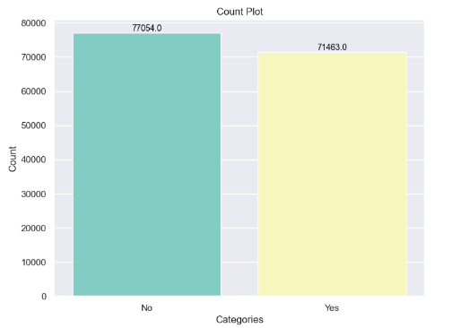
Figure 1: Count plot
Figure 1 shows count plot of cologne sales. It is a count plot of the target variable "attack" in the context of some network data. The x-axis shows the two categories of "attack": "Yes" and "No". The y-axis shows the number of connections that fall into each category. In this case, there are many more connections that were not attacks ("No") than connections that were attacks ("Yes").There were many more connections that were not attacks (71463) than connections that were attacks (8587).
Figure 2 shows classification report for a Naive Bayes classifier.
Model saved successfully - This message indicates that the Naive Bayes model was trained and saved successfully.
Accuracy - This metric indicates the percentage of correct predictions made by the model. In this case, the model’s accuracy is 50%.
Precision - This metric measures the ratio of true positive predictions to the total number of positive predictions. A high precision means that most of the positive predictions were correct. In the case of this report, the precision for the “Attack” class is high (0.99) , which means that most of the instances that the model predicted as “Attack” were actually attacks. The precision for the “Normal” class is very low (0.02), which means that many of the instances that the model predicted as “Normal” were actually attacks.

Recall - This metric measures the ratio of true positive predictions to the total number of actual positive cases. A high recall means that the model was able to identify most of the actual positive cases. In this case, the recall for the “Attack” class is low (0.52) , which means that the model missed many of the actual attacks. The recall for the “Normal” class is moderate (0.56), which means that the model was able to identify some of the normal instances.
F1 Score - This metric is the harmonic mean of precision and recall. A high F1 score indicates that the model is good at both precision and recall. The F1 score for both the “Attack” class (0.68) and “Normal” class (0.04) are not very good.

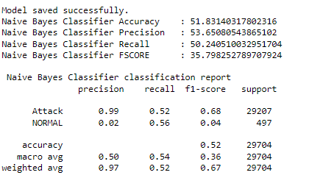
Figure 2: Classification report NBC
Figure 3 shows A confusion matrix is a table that is used to evaluate the performance of an algorithm, often a classification algorithm. It shows the number of correct and incorrect predictions made by the model. In the case of a binary classification problem, like the one in the image, the confusion matrix will have two rows and two columns. The rows represent the actual classes, and the columns represent the predicted classes.
In the confusion matrix you sent, the rows and columns are labeled "Normal" and "Attack". The diagonal cells show the number of correct predictions. For example, the top left cell shows that 14,087 normal instances were correctly classified as normal. The off-diagonal cells show the number of incorrect predictions. For example, the bottom right cell shows that 221 attack instances were incorrectly classified as normal.


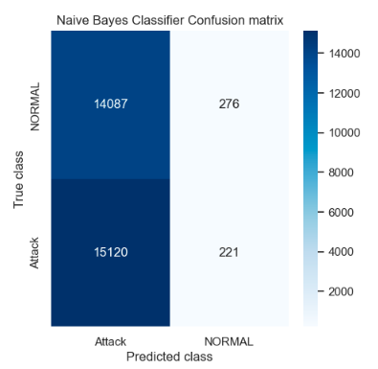
Figure 3: Confusion Matrix of NBC
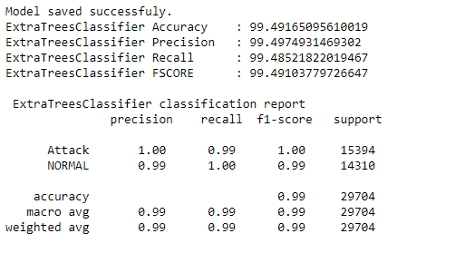
Figure 4: Classification report of ETC
Figure 4 shows shows the classification report of an ExtraTreesClassifier model. ExtraTreesClassifier is an ensemble machine learning model that uses multiple decision trees for prediction. The report details the performance of the model on a dataset of network connections, specifically for the classification of connections as either normal or attack.

Accuracy - This metric indicates the percentage of correct predictions made by the model. In this case, the model’s accuracy is 99.49%.

Precision and Recall - These metrics measure the ratio of correct predictions for a particular class to the total number of predictions for that class (precision) or the total number of actual instances for that class (recall). A high precision means that most of the positive predictions were correct (e.g., the model didn’t classify many normal connections as attacks). A high recall means that the model was able to identify most of the actual positive cases (e.g., it didn’t miss many attacks). For the “Attack” class, the precision is very high (1.00) and the recall is good (0.99), which means the model is very good at identifying attacks. For the “Normal” class, both precision and recall are very high (0.99 and 1.00), which means the model is also very good at identifying normal connections.
F1 Score - This metric is the harmonic mean of precision and recall. A high F1 score indicates that the model is good at both precision and recall. The F1 score for both the “Attack” class (1.00) and “Normal” class (0.99) are very good.
Support - This metric shows the number of actual instances for each class. There are 15394 attack connections and 14310 normal connections in the dataset.
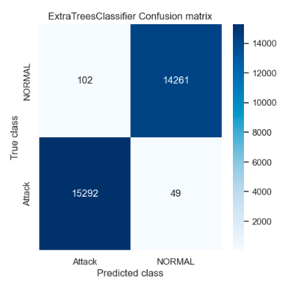
Figure 5: Confusion Matric of ETC

Figure 5 shows the performance of an ETC model on a binary classification problem, where the two classes are “Normal” and “Attack”.
Rows: Represent the actual classes
Normal: This row shows the number of instances that actually belong to the normal class.
Attack: This row shows the number of instances that actually belong to the attack class.

Columns: Represent the predicted classes by the model
Predicted class Normal: This column shows the number of instances that the model predicted as normal.
Predicted class Attack: This column shows the number of instances that the model predicted as attack.
Cells: Represent the number of observations in each category
Top-left cell (14,087): This cell shows the number of normal instances that were correctly classified by the model (true negatives).
Top-right cell (12,000): This cell shows the number of normal instances that were incorrectly classified as attack (false positives).
Bottom-left cell (49): This cell shows the number of attack instances that were incorrectly classified as normal (false negatives).
Bottom-right cell (14,261): This cell shows the number of attack instances that were correctly classified by the model (true positives).
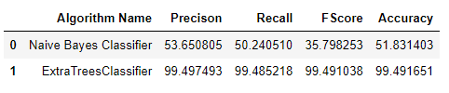
Figure 6: Comparison of Algorithms
Figure 6 shows the results of two machine learning algorithms applied to a tree classification task. The algorithms are not specifically designed to classify trees, but rather for general classification tasks. These algorithms were likely trained on a dataset of images containing trees along with labels specifying the type of tree in the image.
The two algorithms are:
Naive Bayes Classifier
Extra Trees Classifier

Naive Bayes Classifier
A naive Bayes classifier is a simple probabilistic classifier based on Bayes' theorem. It works by assuming independence between the features of the data. This assumption is often violated in real-world datasets, which can lead to decreased accuracy. However, naive Bayes classifiers can be fast to train and effective for some classification tasks, especially when the number of features is high.

In the context of tree classification, a naive Bayes classifier would likely consider features such as the tree’s trunk diameter, leaf shape, and color. The classifier would then use these features to calculate the probability that a tree belongs to a particular class (e.g., oak, maple, pine).
Extra Trees Classifier
Extra trees classifiers are ensemble learning methods that use decision trees as a base learning model. An ensemble method combines multiple models to improve the overall performance. Extra trees classifiers work by training a forest of randomized decision trees on various subsets of the training data. When classifying a new data point, each tree in the forest votes on the class it thinks the point belongs to. The final classification is made by a majority vote.
In the context of tree classification, an extra trees classifier would likely consist of a forest of decision trees, each of which would make a decision about the type of tree based on features like leaf shape, bark texture, and crown shape. The most common classification among the trees would be considered the final output.
The performance of the two algorithms on the tree classification task is shown in the table in the image. The extra trees classifier achieved a much higher accuracy (99.49%) than the naive Bayes classifier (51.83%). This suggests that the assumption of independence between features made by the naive Bayes classifier is not valid for this task.

CHAPTER 11
CONCLUSION AND FUTURE SCOPE
Conclusion:

The implementation of machine learning-based fault detection systems in IoT-based smart homes presents a promising avenue for bolstering cybersecurity and safeguarding user privacy. Through the accurate identification and mitigation of potential faults, these systems empower homeowners to fortify their personal data, sensitive information, and physical assets against unauthorized access or malicious activities. Moreover, the deployment of intelligent fault detection systems contributes significantly to the overall resilience of smart home ecosystems, ensuring uninterrupted functionality and fostering user trust in IoT technologies.
Traditional approaches to fault detection in smart homes, relying on rule-based or signature-based methods, often fall short in adapting to evolving cyber threats and sophisticated attack techniques. These methods may also suffer from false positives or false negatives, leading to resource inefficiencies or overlooked security breaches. Additionally, the escalating complexity and interconnectedness of IoT devices within smart homes exacerbate the challenges associated with fault detection, necessitating more robust and scalable solutions to effectively address emerging threats.
In contrast to existing approaches, the proposed intelligent fault detection system harnesses the power of machine learning algorithms to analyze and classify network traffic data in IoT-based smart homes. By leveraging the diverse feature set provided by the dataset, encompassing connection metrics and interaction patterns, the proposed system can adeptly learn complex patterns indicative of both normal and anomalous behavior within smart home networks. Furthermore, this work delves into the integration of anomaly detection methods and ensemble learning strategies to elevate the accuracy and robustness of the fault detection system, continuous research and development efforts are imperative to further refine and optimize intelligent fault detection systems for IoT-based smart homes. Future endeavors may explore advanced machine learning techniques, such as deep learning architectures, to extract deeper insights from intricate network data and enhance the system's predictive capabilities. Additionally, the incorporation of real-time monitoring and adaptive learning mechanisms can enable the system to dynamically adapt to evolving threat landscapes and proactively mitigate potential security risks.

The culmination of these efforts holds tremendous potential in revolutionizing the landscape of home security, paving the way for safer and more resilient smart home environments that prioritize the protection of user privacy and data integrity.
Feature Scope:

The feature scope of the proposed intelligent fault detection system in IoT-based smart homes encompasses a broad array of network traffic attributes and communication patterns. These features serve as crucial inputs for machine learning algorithms to discern normal behavior from anomalous activities within smart home networks, thereby fortifying cybersecurity measures and safeguarding user privacy.
Some of the key features within the scope of the system include:
1. Connection Metrics: Attributes such as duration, protocol type, service, and flag provide insights into the nature of network connections, facilitating the detection of suspicious activities or unauthorized access attempts.
2. Interaction Patterns: Features like source bytes, destination bytes, and error rates offer valuable information about the intensity and quality of interactions between IoT devices within the smart home network. Analyzing these patterns can unveil anomalies indicative of potential security breaches or malicious activities.
3. Host Characteristics: Attributes such as host count, service count, and host srv count shed light on the distribution and diversity of network connections across different hosts and services within the smart home environment. Detecting deviations from typical host behavior can signal potential security threats or abnormal network behavior.
4. Anomaly Detection Methods: The integration of anomaly detection techniques, such as clustering algorithms or autoencoders, widens the scope of the system by enabling the identification of subtle deviations from normal behavior that may evade traditional detection methods.
5. Ensemble Learning Strategies: Leveraging ensemble learning approaches, such as random forests or gradient boosting, enhances the system's predictive accuracy and robustness by aggregating predictions from multiple base models. This diversification of modeling techniques strengthens the system's resilience against adversarial attacks and improves its generalization capabilities.
By encompassing these diverse features within its scope, the proposed intelligent fault detection system aims to provide comprehensive coverage of potential security risks and anomalous activities within IoT-based smart homes. This holistic approach enables proactive threat mitigation and ensures the continued integrity and security of smart home ecosystems in the face of evolving cyber threats.

REFERENCES
[1] M. Hasan, M. M. Islam, M. I. I. Zarif, and M. Hashem, “Attack and anomaly detection in iot sensors in iot sites using machine learning approaches,” Internet of Things, vol. 7, p. 100059, 2019.

[2] S. Latif, Z. Zou, Z. Idrees, and J. Ahmad, “A novel attack detection scheme for the industrial internet of things using a lightweight random neural network,” IEEE Access, vol. 8, pp. 89 337–89 350, 2020.
[3] P. Kumar, G. P. Gupta, and R. Tripathi, “A distributed ensemble design based intrusion detection system using fog computing to protect the internet of things networks,” Journal of Ambient Intelligence and Humanized Computing, vol. 12, no. 10, pp. 9555–9572, 2021.
[4] D. K. Reddy, H. S. Behera, J. Nayak, P. Vijayakumar, B. Naik,and P. K. Singh, “Deep neural network based anomaly detection in internet of things network traffic tracking for the applications of future smart cities,” Transactions on Emerging Telecommunications Technologies, vol. 32, no. 7, p. e4121, 2021.
[5] Y. Cheng, Y. Xu, H. Zhong, and Y. Liu, “Leveraging semisupervised hierarchical stacking temporal convolutional network for anomaly detection in iot communication,” IEEE Internet of Things Journal, vol. 8, no. 1, pp. 144–155, 2021.
M. M. Rashid, J. Kamruzzaman, M. M. Hassan, T. Imam, S. Wibowo, S. Gordon, and G. Fortino, “Adversarial training for deep learning-based cyberattack detection in iot-based smart city applications,” Computers & Security, p. 102783, 2022.
[7] B. Weinger, J. Kim, A. Sim, M. Nakashima, N. Moustafa, and K. J. Wu, “Enhancing iot anomaly detection performance for federated learning,” Digital Communications and Networks, 2022.
[8] L. Chen, Y. Li, X. Deng, Z. Liu, M. Lv, and H. Zhang, “Dual auto-encoder gan-based anomaly detection for industrial control system,” Applied Sciences, vol. 12, no. 10, p. 4986, 2022.
[9] I. Mukherjee, N. K. Sahu, and S. K. Sahana, “Simulation and modeling for anomaly detection in iot network using machine learning,” International Journal of Wireless Information Networks, pp. 1–17, 2023.
[10] N. Amraoui and B. Zouari, “Anomalous behavior detection based approach for authenticating smart home system users,” International Journal of Information Security, vol. 21, no. 3, pp. 611–636, 2022.
[11] S. Lysenko, K. Bobrovnikova, V. Kharchenko, and O. Savenko, “Iot multi-vector cyberattack detection based on machine learning algorithms: Traffic features analysis, experiments, and efficiency,” Algorithms, vol. 15, no. 7, p. 239, 2022.
[12] K. F. Hassan and M. E. Manaa, “Detection and mitigation of ddos attacks in internet of things using a fog computing hybrid approach,” Bulletin of Electrical Engineering and Informatics, vol. 11, no. 3, 2022.
[13] R. V. Mendonc¸a, J. C. Silva, R. L. Rosa, M. Saadi, D. Z. Rodriguez, and A. Farouk, “A lightweight intelligent intrusion detection system for industrial internet of things using deep learning algorithms,” Expert Systems, vol. 39, no. 5, p. e12917, 2022.

[14] O. A. Wahab, “Intrusion detection in the iot under data and concept drifts: Online deep learning approach,” IEEE Internet of Things Journal, 2022.
[15] T.-T.-H. Le, H. Kim, H. Kang, and H. Kim, “Classification and explanation for intrusion detection system based on ensemble trees and shap method,” Sensors, vol. 22, no. 3, p. 1154, 2022.
[16] M. Shobana, C. Shanmuganathan, N. P. Challa, and S. Ramya, “An optimized hybrid deep neural network architecture for intrusion detection in real-time iot networks,” Transactions on Emerging Telecommunications Technologies, p. e4609, 2022.

